**UNIVERSIDAD TECNOLÓGICA DE QUERÉTARO**

**CESEQ**



**Diplomado en Software Embebido**

Proyecto <Titulo>

DOCUMENTO: Software Development Plan #CESEQ001

Scrum Master: surname, name

Developer. surname, name

Date (YYYYMMDD): 20190405

# Log

|  |  |  |  |
| --- | --- | --- | --- |
| Version | Date (yyyymmdd) | Description | Reviewer |
| 1.0.0 | 20190405 | First release | Pérez, Adbeel |
|  |  |  |  |

# Index

Table of Contents

1. Log 2

2. Index 3

3. Project Scope 4

4. Deliverables 4

4.1 Documents 4

4.2 Code 6

5. Development methodology 6

6. Estimates 6

7. Planning 8

8. Solving Problem Strategy 9

9. Design 9

System Diagram 9

Software Diagram 10

ADC 10

User Interface 11

Controller 11

Flow Diagram 12

Control Diagram 13

9.1. Standards 13

9.2. Naming conventions 13

10. Testing 14

10.1. Verification strategy (black box test) 14

10.2. White box strategy 14

10.3. Cyclomatic Complexity Redundance index 14

11. Release 15

11.1. Integration Tests Strategy 15

11.2. Validation Testing / Functional Testing 15

11.3. Throughput and Flash and RAM measurement 15

# Project Scope

Description of the full project can be observed in the following document:

*<PROJECT_PATH>/1) Requirements/stakeholder/20190501c Requisitos del proyecto integrador CESEQ.docx*

The project was completed with changes to the original scope specified in the aforementioned document. Those changes are listed below:

* Set Point adjustment through UART port: This project did not consider the adjustment of the Set Point using this communication protocol. Set Point is adjusted exclusively through a potentiometer.

Additionally, for those modules where the project description provided several options to proceed, the selections made by this team are listed below:

* Control Algorithm: The close-loop algorithm used for this project is of the PID type.
* Time management for processes: A scheduler was used to execute the system’s tasks.

The requirements for this project were defined in two documents:

1. *<PROJECT_PATH>/1) Requirements/Requisitos_ProyectoIntegrador_DSE.pdf*
2. *<PROJECT_PATH>/1) Requirements/Requisitos_SW_ProyectoIntegrador_DSE.pdf*

The first document contains the System Requirements, while the second document contains the Software Requirements. These documents were generated with the help of an additional software, *ReqView v2.6.2*, which helped us to enumerate the requirements while they were being generated.

It should also be noted that the changes to the original scope and selections mentioned above are reflected in the requirement documents.

# Deliverables

Work products like: Code (hex), Documents (Software Requirement Document, Estimates file, Planning file, Design file, verification file, Functional testing file), or hardware if apply (schematic files, PCB file and Gerber file, general draft) **SHALL** be described here.

## 4.1 Documents

The following table contains the list of documents that will be delivered for this project. Please note that the document location is relative to the path where this document is placed (*<PROJECT_PATH>*).

|  |  |  |
| --- | --- | --- |
| **Document Name** | **Short Description** | **Location** |
| Diagrama_EntradasSalidas.pdf | System diagram for the project (Inputs/Outputs) |  |
| Diagrama_Flujo.pdf | Flow chart for the code |  |
| DSE_Gantt | Gantt Project Planning |  |
| DSE_SW_PI_140619_001 | Software diagram |  |
| Matriz_Riesgos.xlsx | Risk Management File |  |
| Minutas.docx | Document containing dates, topics and resolution for meetings with tutor. |  |
| Requisitos_ProyectoIntegrador_DSE.pdf | System Requirements |  |
| Requisitos_SW_ProyectoIntegrador_DSE.pdf | Software Requirements |  |
| Statement Of Work.docx | Document containing details about how risks, reviews and changes were handled. |  |
| Software Design Document | Contains system and software diagrams. |  |
| Software Standards | Contains details about the software standard used for this project. |  |
| Naming Conventions | Contains details about the naming conventions used inside the code. |  |
| Blackbox Test Baseline | Details Blackbox strategy. |  |
| Whitebox Test Baseline | Details Whitebox strategy. |  |
| Integration Test Baseline | Details Integration testing strategy. |  |
| Validation Test Baseline | Details Validation strategy. |  |
| ThroughputFlashRAM Test Procedure | Details test procedures and results for the throughput, Flash and RAM measurements. |  |
| Blackbox Test Results | Blackbox Test Results |  |
| Whitebox Test Results | Whitebox Test Results |  |
| Integration Test Results | Integration Test Results |  |
| Validation Test Results | Validation Test Results |  |
| Auditoria de calidad V1.0.docx | Format for the Project’s evaluation |  |

## 4.2 Code

The complete RENESAS project can be found in the following zip file:

*<PROJECT_PATH>/3) Design/DSE_Project.zip*

Although several files are contained inside the RENESAS project, only those manually modified are listed in the table below. Please note that the files location is relative to the zip file *(<PROJECT_PATH>/3) Design/DSE_Project.zip*).

|  |  |  |
| --- | --- | --- |
| **File Name** | **Short Description** | **Location** |
| guiapp_event_handlers.c | Event handlers for actions related to the LCD display | src/ |
| main_thread_entry.c | Main function. Timers, Interruptions, PWM are initialized. | src/ |
| common.h | Name definitions used throughout the RENESAS project. | src/ |
|  |  |  |
|  |  |  |
|  |  |  |
|  |  |  |

# Development methodology

In case the team select SCRUM Methodology, it **SHALL** specify the controls like:

* Scrum board,
* Length of the sprint.
* Schedule of the Meetings.
* Positions: Scrum masters, product owner and developers.
* Planning board.

Mencionar sprints, juntas de cada semana con asesor, roles, encargados de épicas

# Estimates

Before making the time estimates for the activities required to complete the project, an analysis was done to identify the facts, assumptions and risks involved; this with the intention of making time estimates closer to reality, organize activities in such way that dependencies do not interfere with deliveries, and identify potential risks at early stages of the planning to be able to mitigate them with the minimum impact possible.

The facts considered for the project are the following:

* There is a workstation available with the following components:
  + PC
  + Internet connectivity
  + Oscilloscope
  + Function Generator
  + DC Power Supply
  + Multimeter
  + SK-S7G2 RENESAS Board
* The team will have a plant available with the following components:
  + Potentiometer
  + H-Bridge Motor Driver
* The following software will be available for the team to use:
  + Matlab
  + E2 Studio IDE
  + Git Hub
* Human Resources:
  + Product Owner (Tutor)
  + 2 Team Members acting as SCRUM Master and Developer

The assumptions made for the project are the following:

* Hardware is available and in good conditions.
* Software is available and has the necessary functionality to aid with the project’s deliverables.
* Laboratory will be available to work on the project on Fridays from 02:00pm to 06:00pm.
* Team members will be available to work on the project on Fridays from 02:00pm to 06:00pm.
* Project requirements will not change from those defined at the beginning of the course.

The risks identified for the project are the following:

* Unable to work with RENESAS Board outside of UTEQ
* Inaccurate planning due to lack of knowledge on project’s complexity.
* Uncalibrated sensor
* Unstable controller
* Damaged components
* Change in requirements
* Team members’ unavailability to work on project outside of Fridays

These risks were monitored throughout the development of the project using a risk matrix. This file can be found in the following path:

*<PROJECT_PATH>/2) Planning/Matriz_Riesgos.xlsx*

Considering all the previous points, it was possible to make estimates for the activities that needed to be done in order to complete the project. Using the SCRUM methodology, the epics and stories shown in the table below were defined.

|  |  |  |
| --- | --- | --- |
| **Activity** | **Type** | **Estimate** |
| Requirements Analysis | Epic |  |
| Read Requirements | Story | 2 |
| Requirements Definition | Story | 6 |
| Instrumentation | Epic |  |
| Hall Effect Sensor Tests | Story | 5 |
| Sensor Characterization | Story | 2 |
| Potentiometer Tests | Story | 2 |
| Potentiometer Characterization | Story | 1 |
| Display Tests | Story | 6 |
| Power | Epic |  |
| H-Driver Tests | Story | 3 |
| H-Driver Characterization | Story | 3 |
| Motor Tests | Story | 2 |
| Power Module Integration | Story | 3 |
| Controller | Epic |  |
| Control Theory Overview | Story | 3 |
| Identify Plant | Story | 2 |
| Obtain Plant’s transfer function | Story | 3 |
| Simulate plant | Story | 2 |
| Develop control algorithm | Story | 2 |
| Implement controller | Story | 5 |
| Test controller | Story | 3 |
| User Interface | Epic |  |
| Set display | Story | 3 |
| Test display | Story | 2 |
| Diagnostics | Epic |  |
| Short to Battery | Story | 3 |
| Short to Ground | Story | 3 |
| Memory corruption | Story | 2 |
| Button in short circuit | Story | 2 |
| Integration | Epic |  |
| Integration of modules | Story | 5 |
| Hardware Tests | Epic |  |
| Software Tests | Epic |  |
| Black Box Tests | Story | 6 |
| White Box Tests | Story | 6 |
| Additional Tests | Story | 2 |
| Project Management | Epic |  |
| Develop SDP | Story | 5 |
| Develop SVP | Story | 5 |
| Develop Architecture document | Story | 3 |
| Generate additional documentation | Story | 8 |

These epics and stories were saved in a GitHub repository, where the tracking was being monitored in order to analyze the progress done throughout the development of the project.

# Planning

* It **SHALL** contain the roll definitions of the team members and their responsibilities.
* All the tasks from estimates section **SHALL** be reflected into the Schedule and assigned to the team. Every task **SHALL** contain the definition of done.
* Remember that any document created, updated, White/Black test execution, Integration testing execution, meetings etc, **SHALL** be contained in this section as part of the activities of the plan.

This section **MUST** be contained in this document or in a different document linked to this section, the new document SHALL be contained at:

<PROJECT_PATH>\2) Planning\7. Planning_20190405.xlsx

Mention roles/responsibilities defined

Mention definition of done for tasks

Assign person to tasks

Reference to Gantt to show planned dates

# Solving Problem Strategy

* This section SHALL contain an FMEA for the full Project considering the sw functionalities defined in the risk analysis from the estimates section.
* In case an error be detected during the development stage, this section SHALL contain a mitigation plan including the 5 whys methodology for hw, sw and document issues.

This section MUST be contained in this document or in a different document linked to this section, the new document SHALL be contained at:

<PROJECT_PATH>\2) Planning\8. DFMEA_20190405.xlsx

# Design

This section **SHALL** contain Static and dynamic modeling diagrams like: block diagram flow diagram, call tree diagram, state machine diagram, sequence diagram and others depending on the programming paradigm.

Additionally, this section SHALL contain control diagram where is defined the: inputs, outputs, noise, and its feedback (if apply).

This section MUST be contained in this document or in a different document linked to this section, the new document SHALL be contained at:

<PROJECT_PATH>\3) Design\9. SoftwareDesignDocument_20190405.docx

Sections 9.1. and 9.2. MUST be contained in this document or MUST be divided into different documents. With the naming defined in every section.

## System Diagram

The System Diagram below identifies the inputs and outputs of the system based on the project’s requirements (image in Spanish).

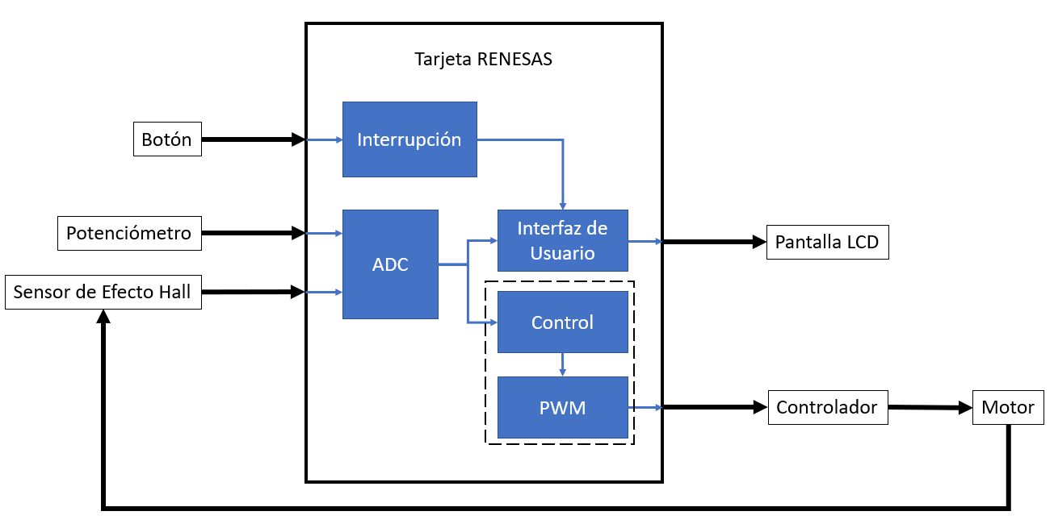

## Software Diagram

To develop the Software Diagram, the *Enterprise Architect v13.5.1351* software was used to identify the modules that would have to be implemented, including their functions, inputs and outputs.

### ADC

For the ADC module, two inputs were considered, one coming from the potentiometer and another one from the Hall Effect Sensor. This module contains three functions, one to read the incoming ADC value, another one to validate the reading and finally one to store the value in its corresponding variable, which could be either POT_VAR or HFS_VAR, the outputs of the module.

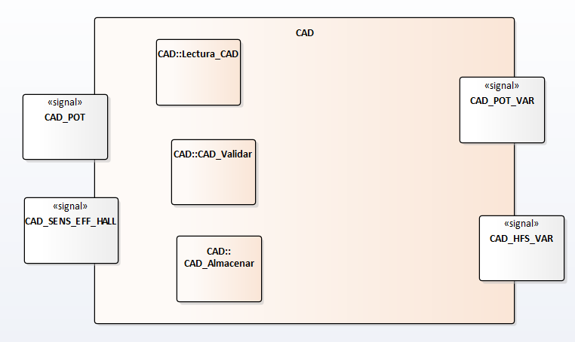

### User Interface

For the User Interface module, its inputs will be the outputs from the ADC module together with the button status that will change the menu shown in the display and the information from the diagnostics. This module will read the inputs and, depending on the menu being displayed, will either convert the ADC and Sensor’s value to the set point and speed respectively or will determine if the monitored values lead to a short to battery or short to ground. Finally, one last function will be in charge of displaying the appropriate message on the display.

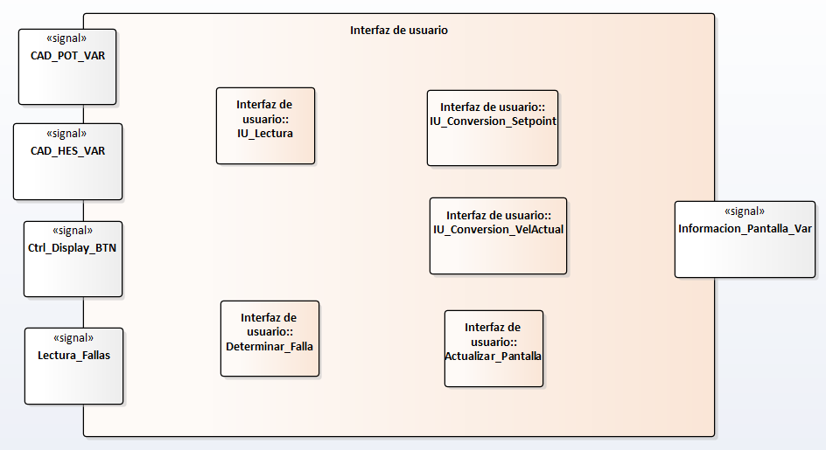

### Controller

For the Controller module, the outputs from the ADC (which have already been validated) will be the inputs. These signals will be read, then they will be used for the control algorithm in order to define the new speed that must be set for the motor and finally that speed will be converted to a duty cycle that will be assigned to the RENESAS output set as PWM.

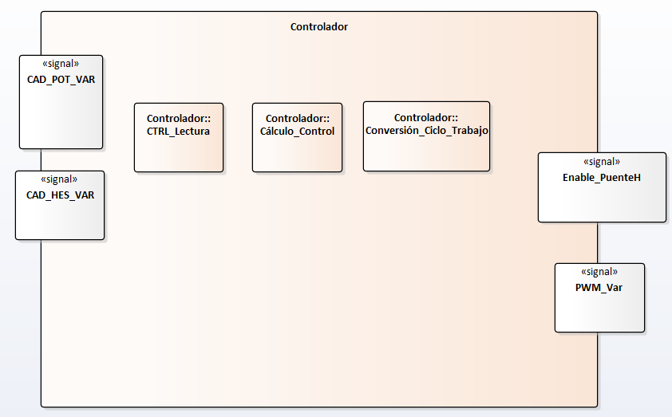

## Flow Diagram

The flow diagram below shows what the program will do throughout its execution. First, it will read and validate information coming from the potentiometer and the Hall Effect sensor, then it will do several tasks, calculate the set point, calculate the actual speed, run the diagnostics, run the controller algorithm, calculate the new duty cycle and then it will send this signal to the power driver. A digital button configured on the display will trigger an interruption that will toggle between the two available menus, either the main menu (showing speed, duty cycle, etc.) or the diagnostics menu.

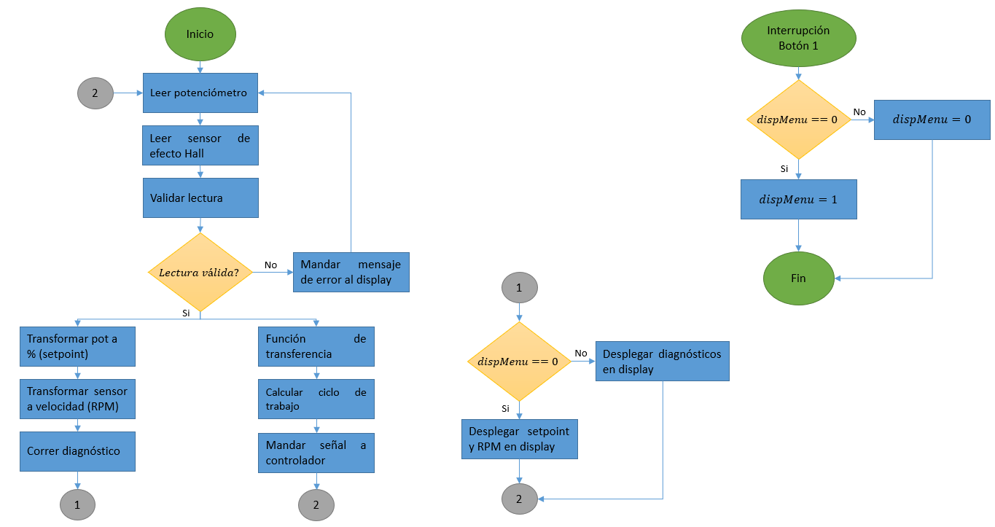

## Control Diagram

PENDING. Add control diagram and description.

## Standards

In case C89-C90, C11 or other standard be used, it SHALL be specified in this section and additionally add the link to the standard used.

Additionally, the tool used to evaluate the standard SHALL be defined here if apply.

This section MUST be contained in this document or in a different document linked to this section, the new document SHALL be contained at:

<PROJECT_PATH>\3) Design\ 9.1. SoftwareStandards_20190405.docx

## Naming conventions

The tags SHALL be defined for: local and global variables, local and global functions, macros, enumerations and structures.

It is **SUGGESTED** to use capital letter for global variables and macros.

In case prefix be used, it is SUGGESTED to consider for variable type, module or file, for example:

uint8_var1

adc_variable1

etc.

File names SHALL have a convention defined in this section, for instance: first letter SHALL be capital.

For folder in code, it SHALL be defined the names or conventions used.

This section MUST be contained in this document or in a different document linked to this section, the new document SHALL be contained at:

<PROJECT_PATH>\3) Design\9.2. NamingConventions_20190405.docx

In code comments, It SHALL contain the requirements which is implemented with the code described.

# Testing

## Verification strategy (black box test)

This section SHALL be contained at:

<PROJECT_PATH>\4) Verification\10.1. BlackboxTest_baseline.docx

…and its results SHALL be located with the date as suffix, as following is indicated:

<PROJECT_PATH>\4) Verification\Results\10.1. BlackboxTest_20190405.docx

Every time a module or feature is implemented, it SHALL contain their tests section and SHALL be contained with the reference to the requirement number in order to have traceability.

## White box strategy

It SHALL define the software which is going to be used, for instance: gtest, junit, sunit, etc.

A document baseline SHALL be created as a reference for all the project implementation. This document SHALL be located at:

<PROJECT_PATH>\4) Verification\10.2. WhiteboxTest_baseline.docx

…and its result SHALL be located at:

<PROJECT_PATH>\4) Verification\Results\10.2. WhiteboxTest_20190405.docx

Every time a module or feature is implemented, every test case SHALL contain a reference to the requirement number in order to have traceability.

## Cyclomatic Complexity Redundance index

<This section is optional>

This section MUST be contained in this document or in a different document linked to this section, the new document SHALL be contained at:

<PROJECT_PATH>\4) Verification\ 10.3. CCRI_20190405.docx

…in case this section is implemented, then its result SHALL be located at:

<PROJECT_PATH>\4) Verification\Results\10.3. CCRI_20190405.docx

# Release

Firmware version number SHALL be defined in this section, and the strategy used for that, an example MUST be:

Date/Hw version/Sw version

20190405/001/ 001

## Integration Tests Strategy

This section SHALL be contained in the planning and reflected in the schedule.

IT **SHALL** be defined a document baseline as a reference for all the project implementation. This document **SHALL** be located at:

<PROJECT_PATH>\4) Verification\11.1. IntegrationTesting_baseline.docx

…and its RESULT SHALL be located at:

<PROJECT_PATH>\4) Verification\Results\11.1. IntegrationTesting_20190405.docx

Every time a module or feature is implemented, every test case SHALL contain a reference to the requirement number in order to have traceability.

This test MUST contain the plant connected or not.

## Validation Testing / Functional Testing

This section SHALL be contained in the planning and reflected in the schedule.

IT **SHALL** be defined a document baseline as a reference for all the project implementation. This document **SHALL** be located at:

<PROJECT_PATH>\4) Verification\11.2. ValidationTesting_baseline.docx

…and its RESULT SHALL be located at:

<PROJECT_PATH>\4) Verification\Results\11.2. ValidationTesting_20190405.docx

Every time a module or feature is implemented, every test case SHALL contain a reference to the requirement number in order to have traceability.

This test SHALL contain the plant connected.

## Throughput and Flash and RAM measurement

This section SHALL be contained in the planning and reflected in the schedule.

It SHALL define the RAM, Flash and Throughtput measurements strategy at:

<PROJECT_PATH>\4) Verification\ 11.3. ThroughputRAMFlash_procedure